Lineup (batting order)

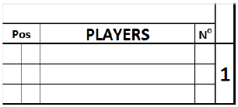
Write in the top box that spans from Pos to No, the name of the team, whose players are listed below.
Pos. | Defensive position of players, indicated by numbers 1 to 9. The designated hitter is identified with DH. A pinch hitter is indicated with PH. A pinch runner is indicated with PR.  Always use the left square for the position. Only in case a player enters a game as PH or PR and gets a fielding position afterwards, write the fielding position in the right square.
PLAYERS | Surname, in block capital letters, and first name, in small letters. When there is an official roster available, use the names from the roster. The first line is for the starting player and the next two are for substitutes. When more than three lines are necessary for any given position in the lineup, the lines after position nine shall be used. In this case the batting order number must be indicated alongside the additional names.
N° | Players’ uniform numbers.

The printed numbers correspond to the batting order lineup. When a team uses a designated hitter, he is listed in the lineup. As the DH bats forthe pitcher, the name of the pitcher shall be written in the proper rows below the lineup.

